**INDUSTRIAL PRACTICAL TRAINING PROJECT REPORT**

# ON

**“SCHOOL MANAGEMENT SYSTEM “**

Submitted in Partial fulfillment of the requirements for the Award of Degree of

# BACHELOR OF TECHNOLOGY

IN

**COMPUTER SCIENCE & ENGINEERING**

## BATCH (2017-21)



**Submitted to: Submitted by:**

HOD (CSE) Sagar Gnawali (171350)

**DEPARTMENT OF COMPUTER SCIENCE & ENGINEERING**

**Amritsar College of Engineering & Technology, Amritsar**

**(Autonomous college under UGC Act – 1956[2(f) and 12(B)] )**

# DECLARATION

I, Dipesh Paudel, hereby declare that the presented report of internship titled “**Multi-purpose Ecommerce**” is uniquely prepared by me during my training period held at Global We Tech Cares (GWTC) company under the guidance of **Er. Bikesh Sapkota.**

During the development of this project, emphasis was given to the problems faced by beginner programmer requirements. As I am submitting this project for the partial fulfillment of the requirement for the award of the degree of B.Tech, I wish to declare that this project is developed by me and none of its components is copied from anywhere.I also confirm that the report is only prepared for my academic requirement, not for any other purpose. It might not be used with the interest of the opposite party of the corporation.

Dipesh Paudel (1900149)

# ACKNOWLEDGEMENT

This is a humble effort to express our sincere gratitude towards those who have guided and helped us to complete this project. A project is a major milestone during the study period of a student. As such this project was a challenge to us and was an opportunity to prove our caliber. We are highly grateful and obliged to each and every one making us help out of problems being faced during the training period. I Dipesh Paudel consider ourselves very fortunate to get an opportunity to conduct the training approval and project assignment by **Global We Tech Cares** . We got an opportunity to get a practical exposure into the actual environment and it provides us a golden opportunity to make my theoretical concept of language more clear. We are able to learn new things that are really helpful for us. We would like to express our special thanks to Er. SANDEEP KAD head of CSE department and the faculty members of department for providing us the opportunity to do six months industrial training. Secondly, we are very much thankful to Er. Bikesh Sapkota and Er. Shaman Jung Shah for providing us the opportunity to do the training in **GWTC** . Also, thankful to all the officials of the organization for their co-operation during our training for providing us necessary guidance without which this project would not have been possible.

**TABLE OF CONTENTS**

|  |  |  |
| --- | --- | --- |
| **Sno.** | **Index** | **Page number** |
| 1 | Training Objective | 5 |
| 2 | About the Organization | 6-7 |
| 3 | Industry Oriented Project Training Details | 8-9 |
| 4 | Hardware and Software Requirements | 10 |
| 4 | Software Module Description | 11-22 |
| 6 | Snapshots | 23-27 |
| 7 | Bibliography | 28 |

# TRAINING OBJECTIVE

**The students having their 6 months Industrial Training** should understand that this is the time when they are exposed to real work life situations that equips them with the required skills which intensify their **job acumen.** In today’s competitive world almost every Engineering of any university has these 6 months Industrial Training as a mandatory part of their academic curriculum with a whole objective of enhancing the knowledge of the students on any one cutting edge technology without which for Industry people the students degree is a mere degree.

As a result of the above said advancement, at present there is a wide appeal between the demand and availability of properly trained manpower .The demand seems like an upward curve to meet this demand already a number of courses are running all over the world. So realizing this fact and according to time demand when computers are necessary and important achievement, we have chosen CSE/IT Branch.

We sincerely hope that the method of presentation of this project will enable us to grasp the details with satisfaction.

# ABOUT THE ORGANIZATION



**Foundation:**

Global We Tech Cares Nepal is one of the best inclusive computer training institutes in Kathmandu, Nepal. Established in 2008, our professional IT Training and Development center has been employing experts in this field to impart professional education to trainees. We offer well-structured complete professional training in various Programming Languages, Graphics & Multimedia, Web Designing as well as Development Training that is based upon the current recruitment needs in the IT market.

**Vision:**

“To empower the nation through generation of computer literates and competent IT

professionals who could serve as valuable resources and responsible innovative citizens.”

**Mission:**

“Global We Tech Cares Nepal’s team is and will be dedicated to develop and impart quality IT training and service to all ; achieving excellence in creative, innovative and up to-date teaching-learning, facilitating effective interactions among faculty, management and students and acting as a contributing institution for the employees, society and all stakeholders.”

**Objectives:**

* To impart value-based IT knowledge and skills
* To create employment in IT sector
* To bridge the gap between skilled manpower and aspiring IT companies
* To act as a platform for grooming one's IT skill

**Services We Offer:**

* **Industrial Training:** From corporate training to end user training and technical

Trainings like Python Django, MERN stack, MEAN stack and ROR etc.,

# INDUSTRY ORIENTED PROJECT DETAILS

**ECONOMIC FEASIBILITY :**

Economic analysis determines the benefits and the savings that are expressed from a candidate system and compares those costs. Its benefits outweigh the costs. Otherwise, further justification or alterations in the proposed system will have to be made if it is to have a chance of being approved. This is an ongoing effort that improves in accuracy at each phase of the system life cycle.It looks at the financial aspects of the project. It determines whether the management has enough resources and budget to invest in the proposed system and the estimated time for the recovery of cost incurred. It also determines whether it is worthwhile to invest the money in the proposed project. Economic feasibility is determined by the means of cost benefit analysis.

**TECHNICAL FEASIBILITY:**

It is a measure of the practically of a specific technical solution and the availability of technical resources and expertise

* The proposed system uses Bootstrap, CSS, HTML, JavaScript as front-end and Python Django as back-end tool.
* Django is a popular tool used to design and develop database objects such as table views, indexes. It is a framework with a set of rules.
* The above tools are readily available, easy to work with and widely used for developing commercial application

Hardware used in this project are i5 processor 2.4GHz, 8GB DDR4 memory, 1TB hard disk. These hardware were already available on the existing computer system. The software like Visual Code Studio, Atom Editor, Anaconda IDE and operating system WINDOWS 11 used were already installed on the existing computer system. So no additional hardware and software were required to purchase and it is technically feasible.

**OPERATIONAL FEASIBILITY:**

This website is simple and easy to use. No major training and new skills are required as it is based on the Django set of rules and regulations.

It only requires laptop to login to this website .

* It will help in time saving and fast processing.
* New product will provide all the benefits of the present system with better performance.
* Better management.
* New product will provide all the benefits of the present system with better performance.
* Improved information, better management and collection of the reports.
* No major training and new skills are required as it is based on the NOSQL model.

From these points our project is operationally feasible too.

**REQUIREMENT ANALYSIS**

1. This website will reduce the burden over the coder who wants to work remotely.
2. This website provides the facility to connect multiple users and write along with each other.
3. This also helps companies when their developer is not available he/she can code with the team on platform.

**HARDWARE & SOFTWARE REQUIREMENTS**

**Hardware Requirements:**

|  |  |  |
| --- | --- | --- |
| **Hardware Environment (Deployment Server)** | | |
| **PC** | Windows 7 or above | |
| **Processor** | Intel Dual Core, 1.6GHz or above. | |
| **RAM** | 2GB RAM | |
| **HDD** | 100 GB or above | |
| **Hardware Environment (End user’s PC)** | | |
| **PC** | | PC (Windows) |
| **Processor** | | Intel Dual Core, 233 MHz or equivalent. |
| **RAM** | | 1 GB RAM |
| **HDD** | | 500 MB of free HDD space for Internet Cache |

**Software Requirements:**

|  |  |  |
| --- | --- | --- |
| **Software Environment (Deployment Server)** | |  |
| **Operating System** | Window 7 or above |  |
| **Front end** | CSS, HTML, Bootstrap, JavaScript |  |
| **Back end** | Python Django |  |

# Project Introduction

Multi-purpose Ecommerce Website is a Dynamic Website built using the high end and demanding technologies like Django and JavaScript. This project is faster, more fluid then all other multi-page web apps that are built with regular javascript, HTML and css .

Basically this project allows the user to add to cart with industry standard authentication using JWT(JSON Web Tokens). After login into the system the user can update the various data of the website and manage the contents.

This is a school website project, where supplier can upload things which are needed on a daily basis. The project is made using Python Django programming language.Django is a library of Python which is used to build user interactive interfaces. We have used django and SQLite as databases. Django supports almost all kinds of databases. In the project there is use of class components and functional components which are used to make interactive modules.

**MODULES OF THE PROJECT**

* **Home:**

Home page as welcome page. It consist of product and technology details and various items.

* **Login:**

Superuser can login to start the session or join the existing session and start to see the code editor to start coding.

* **Register:**

Superuser have to register and then login to start using the platform.

* **Gallery:**

You can see all the photos of products here. provide a slight information about the product.

* **Cart**

You can see the products you added to the cart.

* **Add To Cart**

You can add the product you like to cart

* **Category**

Helps to choose the category you want to see the specific product for.

## SOFTWARE MODULE DESCRIPTION

**Front End:**

* CSS
* HTML
* Bootstrap
* Javascript

**Back End:**

* Django
* SQLite

**OTHER TOOLS & LIBRARIES :**

**JWT** - JSON web tokens used for authentication.

**CSRF Token** – It is built-in function available in Django for session security.

## INTRODUCTION TO DJANGO STACK

Python Django is a popular, free and open-source web framework used for building web applications. It is written in Python and follows the model-template-view architectural pattern. It has a built-in administration interface, ORM support, and a large and active community. Django also provides a lot of built-in functionality to handle common web development tasks such as user authentication, URL routing, and database model management. It is used by many large companies such as Instagram and Pinterest.

**A Closer Look at Django Components**

1. **Models**:

Models in Django are used to define the structure of data in the application and the fields and behaviors of the objects that will be stored in the database. They are defined as Python classes and inherit from the base Model class provided by Django. Fields, such as CharField and IntegerField, are used to define the structure of the data and the types of values that will be stored. Models also have built-in methods for performing common database operations, such as saving and deleting objects. Additionally, they support relationships such as one-to-many, many-to-many, and one-to-one, which allows related data to be easily linked and queried. This makes it easy to create and manage complex data structures and relationships. With the built-in ORM support, developers can easily interact with the database and perform CRUD operations on the models. Overall, models are an important component of Django development, providing a simple and powerful way to define and work with data.

1. **Templates:**

Django templates are a way to separate the presentation of a Django web application from its logic. They allow developers to define the structure of a web page and fill it with dynamic content using template tags and variables. Django's template engine also supports template inheritance, which allows for reusing common elements across multiple templates. The templates can be written in various languages such as Django template language, Jinja, or Mako. They are an essential tool for creating web pages with Django, as it enables the separation of concerns between the application logic and the presentation of the data.

**3. Views:**

Django views are Python functions that handle the logic for a specific part of a Django web application. They are responsible for processing and generating a response for a specific web page or endpoint. Views can also interact with models to retrieve or manipulate data, and use templates to structure the HTML output. Django views are typically defined in the views.py file of an app and are mapped to URLs using URLconf. They provide a way to separate the logic of a web page from the presentation, allowing for more maintainable and modular code.

**4. Admin interface:**

Django's admin interface is a built-in feature that allows for easy management of a Django project's models. It provides a web-based interface for performing CRUD operations on the models and their associated data. The admin interface is automatically generated based on the models defined in the project and requires minimal setup. It also allows for customization, such as adding new fields or customizing the layout. The Django admin interface is a useful tool for managing data and performing administrative tasks, without the need to build custom views or forms.

**The Benefits of the Django**

The Django is a high-level web framework that offers many benefits for web development. It provides a clear and pragmatic structure for building web applications, making it easy to maintain and scale. Django's built-in ORM allows for easy interaction with databases, reducing the complexity of database operations. Django also includes a built-in admin interface, providing a convenient way to manage and manipulate data. The framework has a large and active community, which results in a wealth of tutorials, packages, and resources. Additionally, Django's security features help to prevent common web attacks and protect the applications.

**Features of Django:**

Following are some of the important features that make Node.js the first choice of software architects.

* Model-View-Controller (MVC) architecture: Django follows the Model-View-Controller (MVC) architectural pattern, which separates the application logic into three interconnected components: models, views, and templates. This separation of concerns allows for more maintainable and modular code.
* Object-Relational Mapping (ORM): Django's built-in ORM allows for easy interaction with databases, reducing the complexity of database operations. The ORM maps Python objects to database tables and provides a convenient API for performing CRUD operations.
* Automatic admin interface: Django provides an automatic admin interface that allows for easy management of a project's models and associated data. This feature is generated based on the models defined in the project and requires minimal setup.
* Template engine: Django's template engine allows for the separation of presentation and logic, making it easy to create reusable templates and structure HTML output. The templates can be written in various languages such as Django template language, Jinja, or Mako.
* Security features: Django includes a number of built-in security features to protect web applications from common attacks, such as cross-site scripting (XSS) and SQL injection. It also includes a built-in protection against clickjacking and cross-site request forgery (CSRF) attacks.

## INTRODUCTION TO JAVASCRIPT

**What is JAVASCRIPT?**

JavaScript is a scripting or programming language that allows you to implement complex things on web pages — every time a web page does more than just sit there and display static information for you to look at — displaying timely content updates, interactive maps, animated 2D/3D graphics, scrolling video jukeboxes, etc. — you can bet that JavaScript is probably involved. It is the third layer of the layer cake of standard web technologies, two of which

([HTML](https://developer.mozilla.org/en-US/docs/Learn/HTML) and [CSS](https://developer.mozilla.org/en-US/docs/Learn/CSS)) we have covered in much more detail in other parts of the Learning

**What is JAVASCRIPT?**

JavaScript is a scripting or programming language that allows you to implement complex things on web pages — every time a web page does more than just sit there and display static information for you to look at — displaying timely content updates, interactive maps, animated 2D/3D graphics, scrolling video jukeboxes, etc. — you can bet that JavaScript is probably involved. It is the third layer of the layer cake of standard web technologies, two of which ([HTML](https://developer.mozilla.org/en-US/docs/Learn/HTML) and [CSS](https://developer.mozilla.org/en-US/docs/Learn/CSS)) we have covered in much more detail in other parts of the Learning Area.

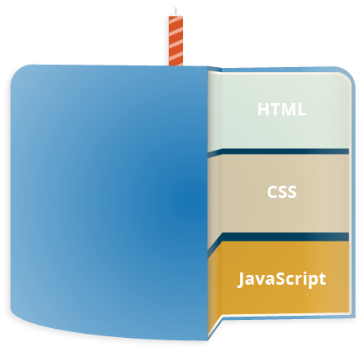

* [HTML](https://developer.mozilla.org/en-US/docs/Glossary/HTML) is the markup language that we use to structure and give meaning to our web content, for example defining paragraphs, headings, and data tables, or embedding images and videos in the page.
* [CSS](https://developer.mozilla.org/en-US/docs/Glossary/CSS) is a language of style rules that we use to apply styling to our HTML content, for example setting background colors and fonts, and laying out our content in multiple columns.
* [JavaScript](https://developer.mozilla.org/en-US/docs/Glossary/JavaScript) is a scripting language that enables you to create dynamically updating content, control multimedia, animate images, and pretty much everything else. (Okay, not everything, but it is amazing what you can achieve with a few lines of JavaScript code.)

**What can JAVASCRIPT do?**

The core client-side JavaScript language consists of some common programming features that allow you to do things like:

* Store useful values inside variables. In the above example for instance, we ask for a new name to be entered then store that name in a variable called name.
* Operations on pieces of text (known as "strings" in programming). In the above example we take the string "Player 1: " and join it to the name variable to create the complete text label, e.g. ''Player 1: Chris".
* Running code in response to certain events occurring on a web page. We used a [click](https://developer.mozilla.org/en-US/docs/Web/Events/click) event in our example above to detect when the button is clicked and then run the code that updates the text label.
* And much more!

What is even more exciting however is the functionality built on top of the client-side JavaScript language. So-called Application Programming Interfaces (APIs) provide you with extra superpowers to use in your JavaScript code.APIs are ready-made sets of code building blocks that allow a developer to implement programs that would otherwise be hard or impossible to implement. They do the same thing for programming that ready-made furniture kits do for home building — it is much easier to take ready-cut panels and screw them together to make a bookshelf than it is to work out the design yourself, go and find the correct wood, cut all the panels to the right size and shape, find the correct-sized screws, and *then* put them together to make a bookshelf.

**IDE: (Integrated Development Environment)**

An integrated development environment (IDE) (also known as integrated design environment, integrated debugging environment or interactive development environment) is a software application that provides comprehensive facilities to computer programmers for software development . An IDE normally consists of:

* a source code editor
* a compiler and/or an interpreter
* build and automation tools
* a debugger

The boundary between an integrated development environment and other parts of the broader software development environment is not well-defined. Sometimes a version control system and various tools are integrated to simplify the construction of a GUI. Many modern IDEs also have a class browser , an object inspector, and a hierarchy diagram, for use with object oriented software development.

**Database Access**

Django supports nearly every database out there like SQL, NOSQL- Mysql, postgresql, MongoDB. It also supports there native drivers and you can also hook up the third party drivers like with mongodb you can use mongoose which has far good methods and support for the querieng.

**File Access**

In Windows, for example, a file can be any item manipulated, edited or created by the user/OS. That means files can be images, text documents, executables, and much more. Most files are organized by keeping them in individual folders.

In Python, a file is categorized as either text or binary, and the difference between the two file types is important.

Text files are structured as a sequence of lines, where each line includes a sequence of characters. This is what you know as code or syntax.

Each line is terminated with a special character, called the EOL or End of Line character. There are several types, but the most common is the comma {,} or newline character. It ends the current line and tells the interpreter a new one has begun.

A backslash character can also be used, and it tells the interpreter that the next character – following the slash – should be treated as a new line. This character is useful when you don’t want to start a new line in the text itself but in the code. A binary file is any type of file that is not a text file. Because of their nature, binary files can only be processed by an application that knows or understands the file’s structure. In other words, they must be applications that can read and interpret binary.

**FRONT END : HTML CSS , BOOTSTRAP:**

**INTRODUCTION OF HTML:**

* HTML stands for Hyper Text Markup Language.
* HTML describes the structure of Web pages using markup.
* HTML elements are the building blocks of HTML pages.
* HTML elements are represented by tags.
* HTML tags label pieces of content such as "heading", "paragraph", "table", and so on.

**TYPES OF TAGS:**

* Paired Tag
* Singular Tag
* Self-Closing Tag

* **Paired Tag:-**It is also called container tag. A tag is said to a paired. If it along with a companion tag or closing tag appears at the end.
* **Singular Tag:-**The second type of tag is the singular tag, which is also known as stand alone tag or empty tag. The stand alone tag does not have companion tag or closing tag.
* **Self-closing Tag:-**A self-closing tag is an element of HTML code that has evolved in the language. Typically the self-closing tag makes use of a ”/” character in order to effectively close out a beginning tag enclosed in sideways carets.

**INTRODUCTION OF CSS:**

* **CSS** stands for **C**ascading **S**tyle **S**heets
* CSS describes **how HTML elements are to be displayed on screen, paper, or in other**

**media**

* CSS **saves a lot of work**. It can control the layout of multiple web pages all at once
* External stylesheets are stored in **CSS files**

**CSS PROPERTIES:**

* Text properties
* List properties
* Border properties
* Font properties

**INTRODUCTION OF JAVASCRIPT**

**JavaScript** is a client side, interpreted, object oriented, high level scripting language, while Java is a client side, compiled, object oriented high level language. Now after that mouthful, here's what it means. Programs are passed to the computer that the browser is on, and that computer runs them.

**DATA TYPES OF JAVASCRIPT**

* Boolean.
* Null.
* Undefined.
* Number.
* String.
* Symbol.
* Object.
* Loops

**POPPING AND PUSHING:**

When you work with arrays, it is easy to remove elements and add new elements. This is what popping and pushing is: Popping items **out** of an array, or pushing items **into** an array.

**SHIFTING ELEMENTS:**

Shifting is equivalent to popping, working on the first element instead of the last. The **shift()** method removes the first array element and "shifts" all other elements to a lower index.

**CHANGING ELEMENTS:**

Array elements are accessed using their **index number.**

**DELETING ELEMENTS:**

Since JavaScript arrays are objects, elements can be deleted by using the JavaScript operator delete**.**

**BOOTSTRAP:**

**Bootstrap** is a free and open-source collection of tools for creating websites and web applications. It is the most popular HTML, CSS, and JavaScript framework for developing responsive, mobile-first web sites. It solves many problems which we had once, one of which is the cross browser compatibility issue.

**HISTORY OF BOOTSTRAP:**

**Bootstrap**, originally named Twitter Blueprint, was developed by Mark Otto and Jacob Thornton at Twitter as a framework to encourage consistency across internal tools. Before **Bootstrap**, various libraries were used for interface development, which led to inconsistencies and a high maintenance burden.

**USES OF BOOTSTRAP**

Bootstrap is a framework to help you design websites faster and easier. It includes HTML and **CSS** based design templates for typography, forms, buttons, tables, navigation, modals, image carousels, etc. It also gives you support for JavaScript plugins.

**BOOTSTRAP CONTAINER CLASS**

**Bootstrap Container**. In **Bootstrap**, **container** is used to set the content's margins dealing with the responsive behaviors of your layout. It contains the row elements and the row elements are the **container** of columns (known as grid system). The **container class** is used to create boxed content

**BOOTSTRAP SPAN CLASS**

The Bootstrap "span" classes are used in the bootstrap grid system. The documentation shows columns labeled with numbers, each number represents the span class used for this container. Offset are shown right in the next section, they define how many empty columns should be to the left of the span.

**SM AND MD IN BOOTSTRAP**

The Bootstrap grid system has four classes: xs (phones), sm (tablets), md (desktops), and lg (larger desktops). The classes can be combined to create more dynamic and flexible layouts. Tip: Each class scales up, so if you **wish** to set the same widths for xs and sm, you only need to specify xs

**SCREENSHOTS**



**(fig-01: Home Screen)**

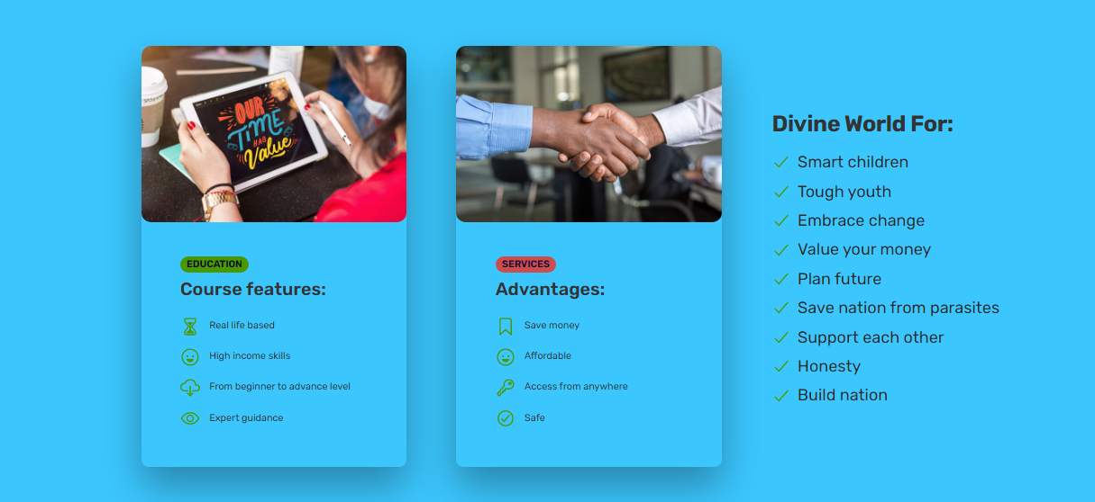

**(fig-02:Course and Features Screen)**

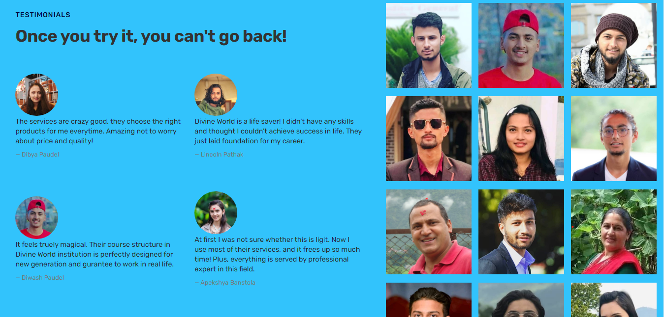

**(fig-03:Testimonials)**

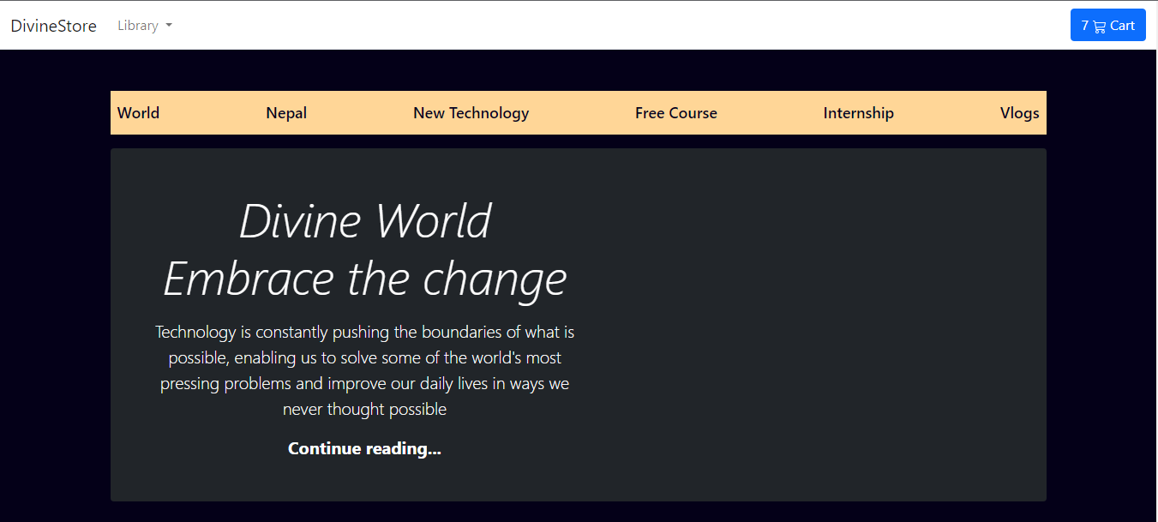

**(fig-04:Divine Store Ecommerce Screen)**

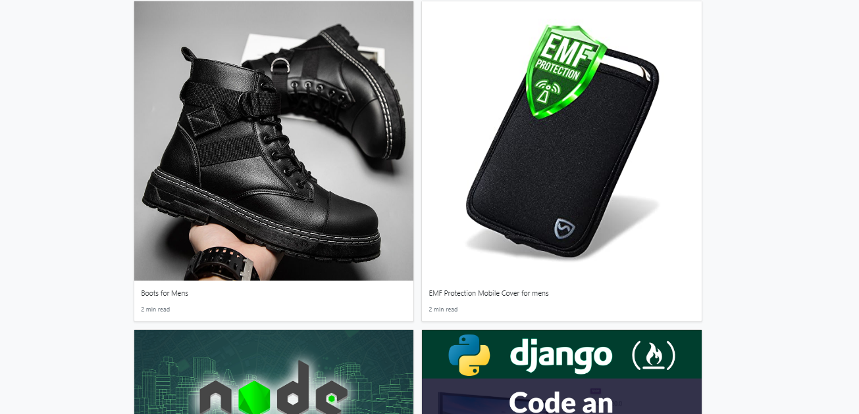

**(fig-05: Products)**

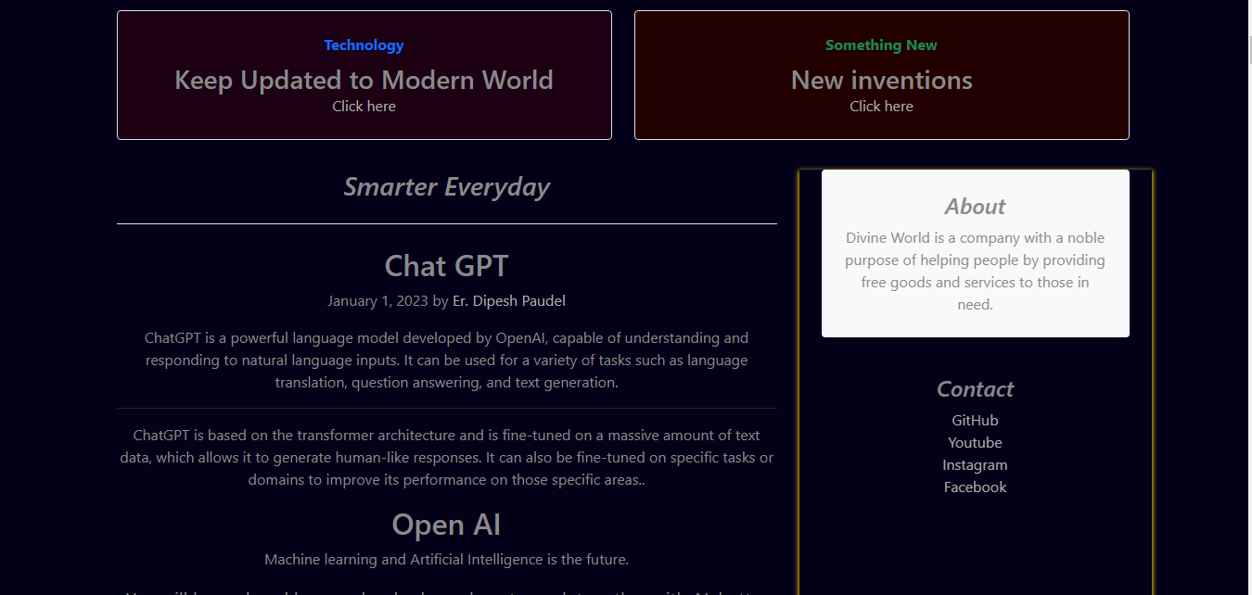

**(fig-06:Information about Technology Screen)**

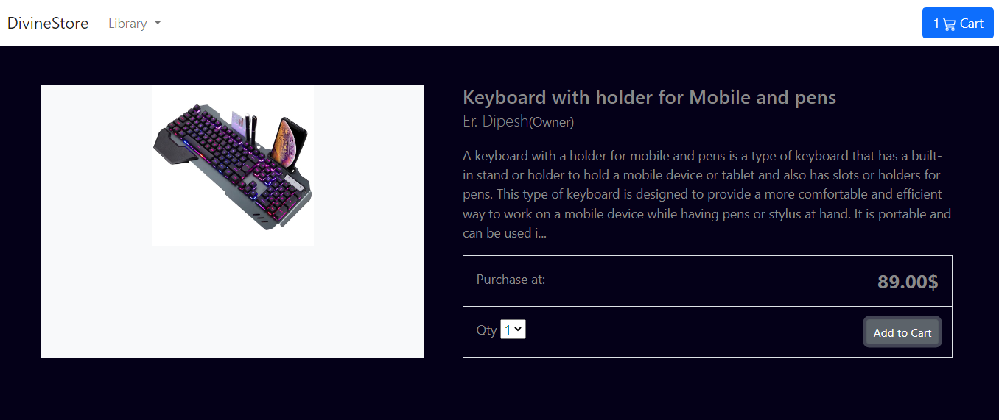

**(fig-07: Product Description Page)**

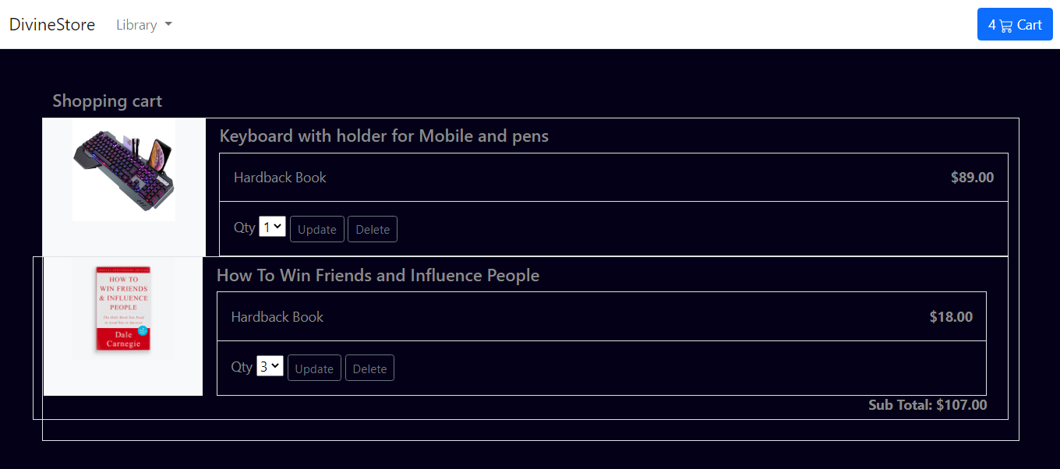

**(fig-08:Items in Cart)**

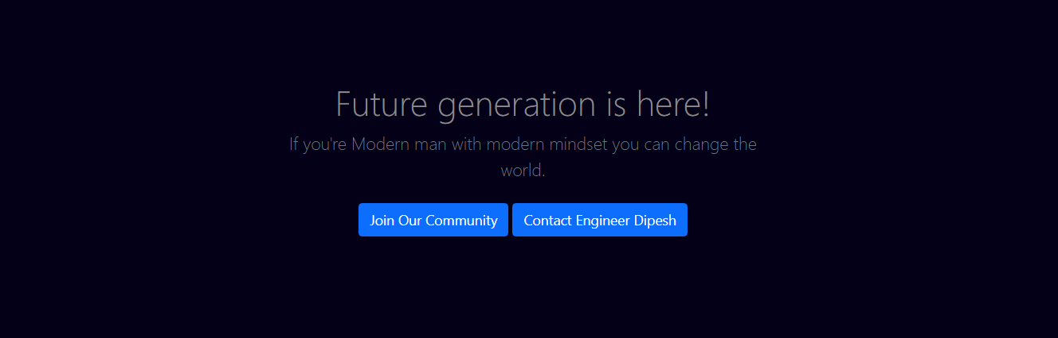

**(fig-09:Join our Committee and Contact screen)**

**BIBLIOGRAPHY**

* http://www.w3schools.com
* <https://developer.mozilla.org/en-US/>
* <https://reactjs.org/>
* [https://stackoverflow.com](https://stackoverflow.com/)
* <https://mongoosejs.com/docs/>
* MERN/MEANstack study notes by the Institution.